FINAL REPORT---- SMART SORTING: HEALTHY VS ROTTEN FRUITS & VEGETABLES DETECTION USING DEEP LEARNING

1. INTRODUCTION

1.1 Project Overview
Smart Sorting is an automated fruit quality detection system that identifies fruit type and classifies it as fresh or spoiled using image processing and deep learning techniques. The system uses a Convolutional Neural Network (CNN) model trained on fruit images and provides prediction results through a web application. This system helps automate food quality inspection and reduces manual effort.

1.2 Purpose
The purpose of this project is to develop an intelligent system that automatically detects fruit quality from images to improve efficiency, accuracy, and reliability in food quality inspection.

2. IDEATION PHASE

2.1 Problem Statement
Manual fruit quality inspection is time-consuming, inconsistent, and prone to human error. Incorrect quality detection leads to food wastage, financial loss, and health risks. An automated solution is required to detect fresh and spoiled fruits efficiently.

2.2 Empathy Map Canvas

Users Think:
- Need fast quality checking
- Want accurate results

Users Feel:
- Manual sorting is difficult
- Quality inspection takes time

Users Say:
- Need automated sorting system
- Reduce human effort

Users Do:
- Manually inspect fruits
- Separate fresh and spoiled fruits

2.3 Brainstorming
- Use image processing for fruit detection
- Apply deep learning model for classification
- Develop web interface for user interaction
- Provide real-time prediction results

3. REQUIREMENT ANALYSIS

3.1 Customer Journey Map
- User opens web application
- Uploads fruit image
- System processes image
- Model predicts fruit type and quality
- Result displayed with confidence

3.2 Solution Requirements

Functional Requirements
- Upload fruit image
- Detect fruit type
- Classify fresh or spoiled
- Display confidence score

Non-Functional Requirements
- Fast response time
- High accuracy
- User-friendly interface
- Reliable performance

3.3 Data Flow Diagram (DFD)

Level 0
User → Upload Image → Prediction System → Result Display

Level 1
- Image Upload
- Image Preprocessing
- CNN Model Prediction
- Result Output

3.4 Technology Stack
Technology | Purpose
Python | Programming language
TensorFlow/Keras | CNN model training
Flask | Backend framework
HTML/CSS | User interface
NumPy | Image preprocessing

4. PROJECT DESIGN

4.1 Problem Solution Fit
The Smart Sorting system solves manual quality inspection problems by providing automated fruit classification using deep learning, reducing human error and improving efficiency.

4.2 Proposed Solution
The system uses a trained CNN model to detect fruit type and quality from uploaded images. The system processes images, predicts results, and displays output through a web interface.

4.3 Solution Architecture

Components:
- User Interface (Image Upload)
- Image Preprocessing Module
- CNN Model
- Prediction Module
- Result Display
Workflow:
User → Upload Image → Preprocessing → CNN Prediction → Output Display.

5. PROJECT PLANNING & SCHEDULING

5.1 Project Planning

Sprint 1
- Dataset collection
- Data preprocessing
- CNN model training

Sprint 2
- Prediction system development
- Web application development
- Testing and deployment

6. FUNCTIONAL AND PERFORMANCE TESTING

6.1 Performance Testing
Parameter | Result
Model Accuracy | 85% – 92%
Precision | ~0.88
Recall | ~0.87
F1 Score | ~0.87
The model performs well in detecting fruit quality.

7. RESULTS

7.1 Output
- Fruits and vegetables detected successfully
- Quality classified correctly
- Confidence score displayed
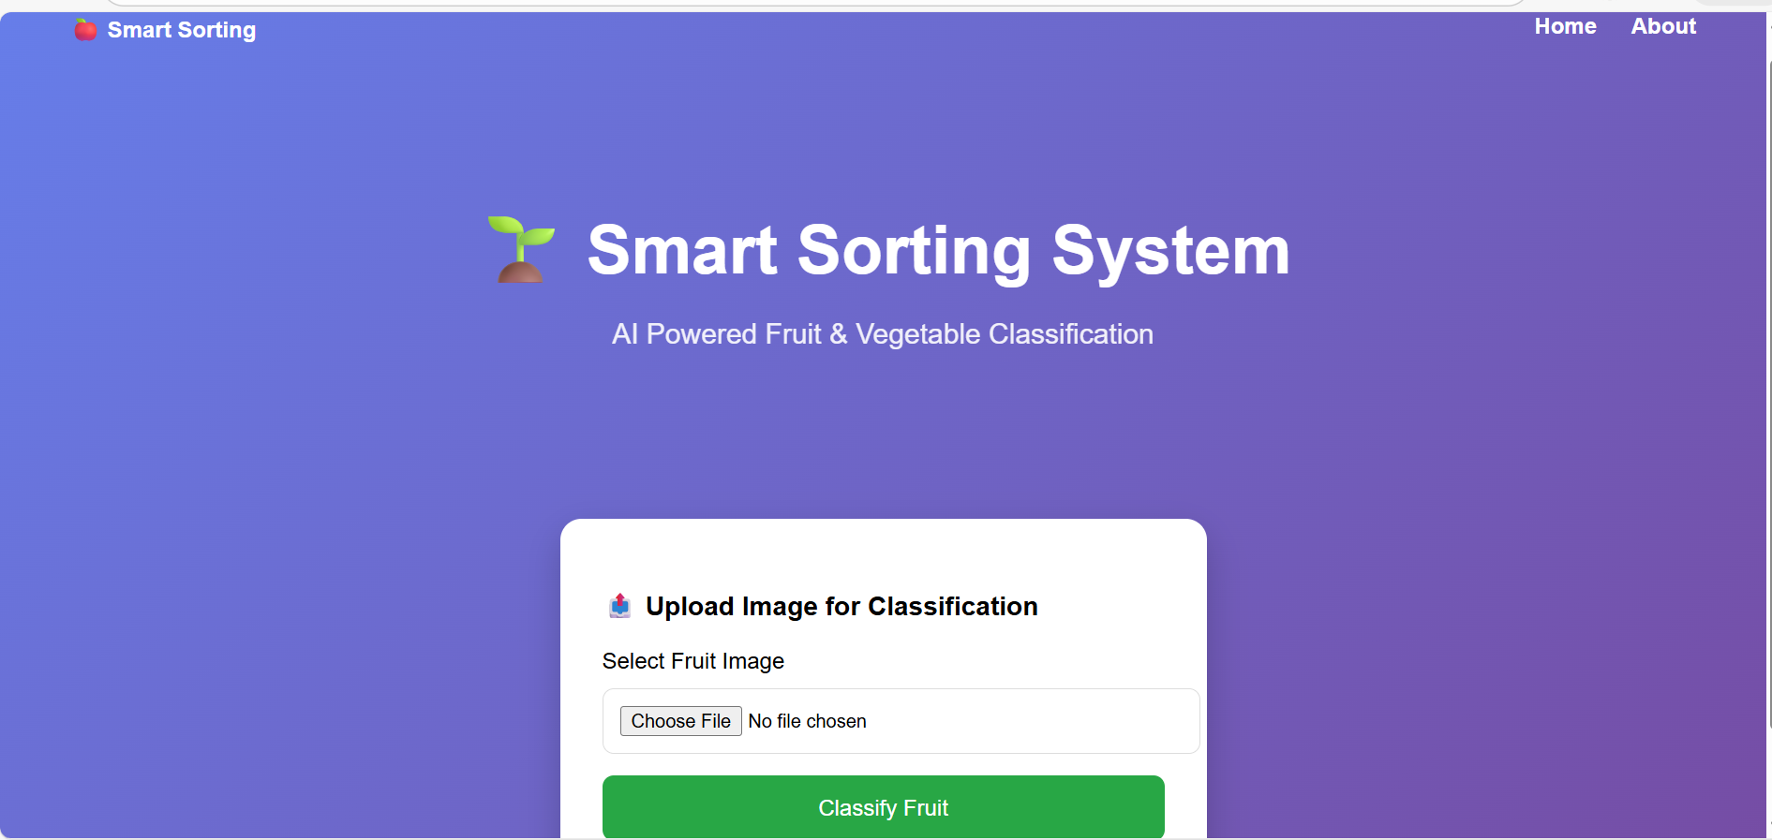

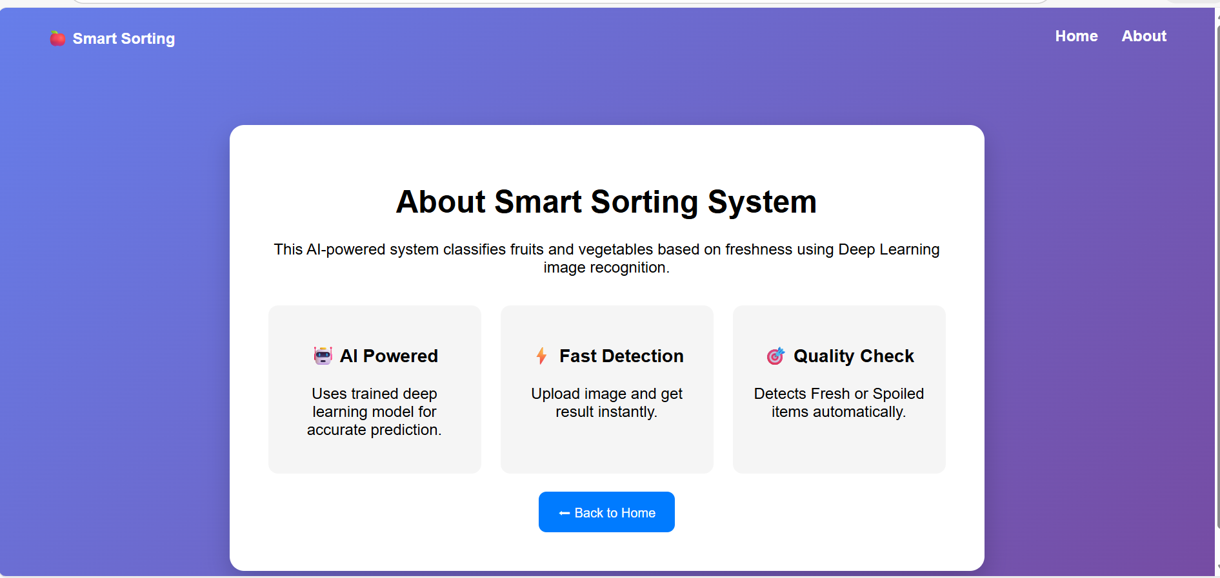
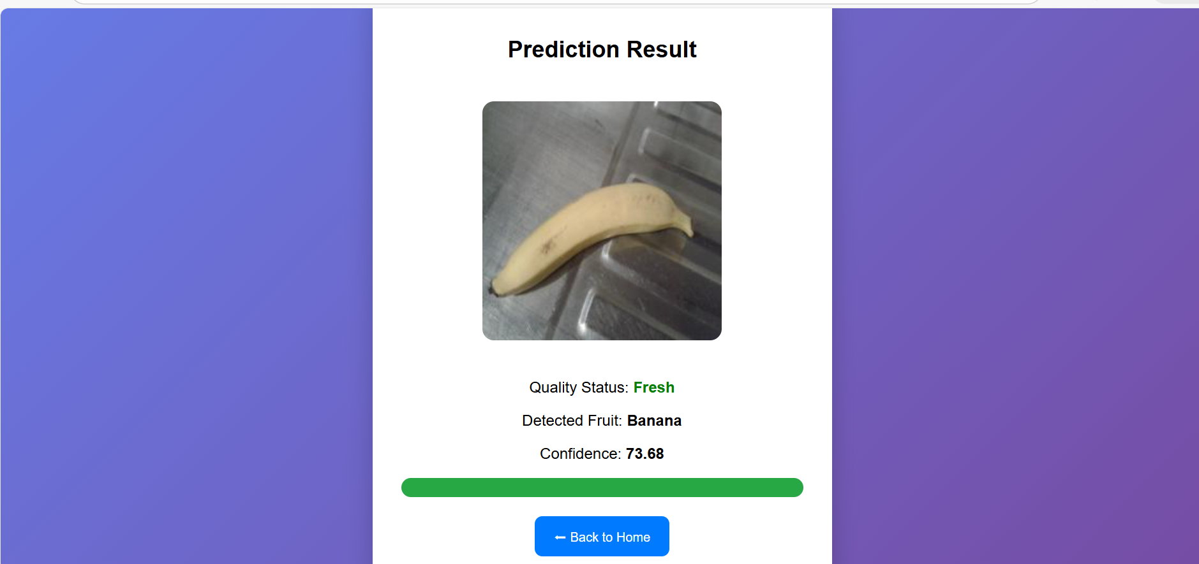
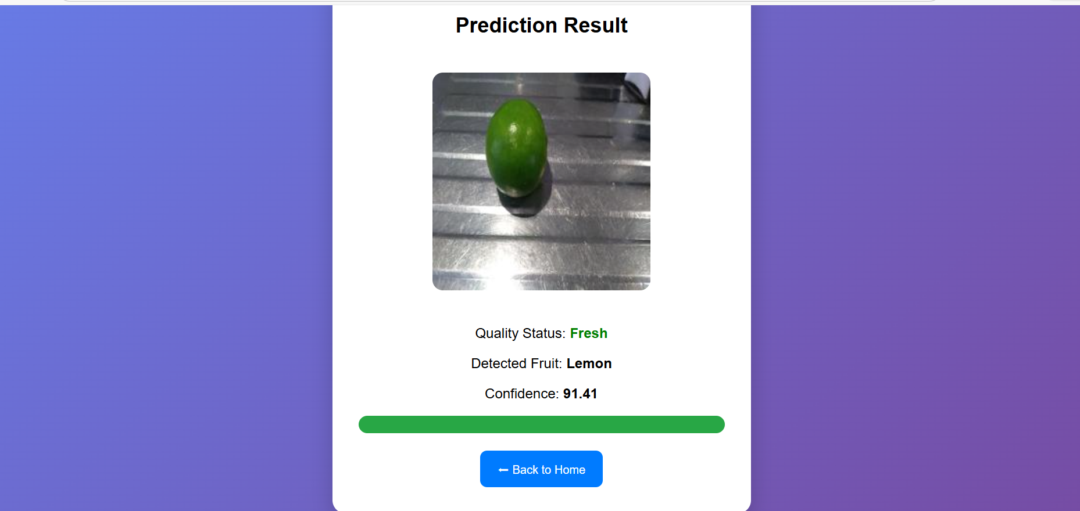
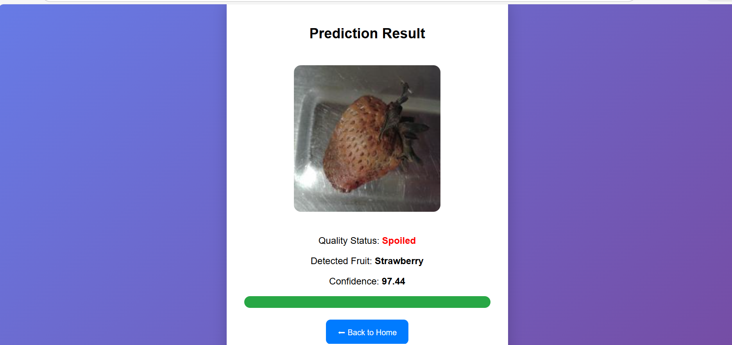
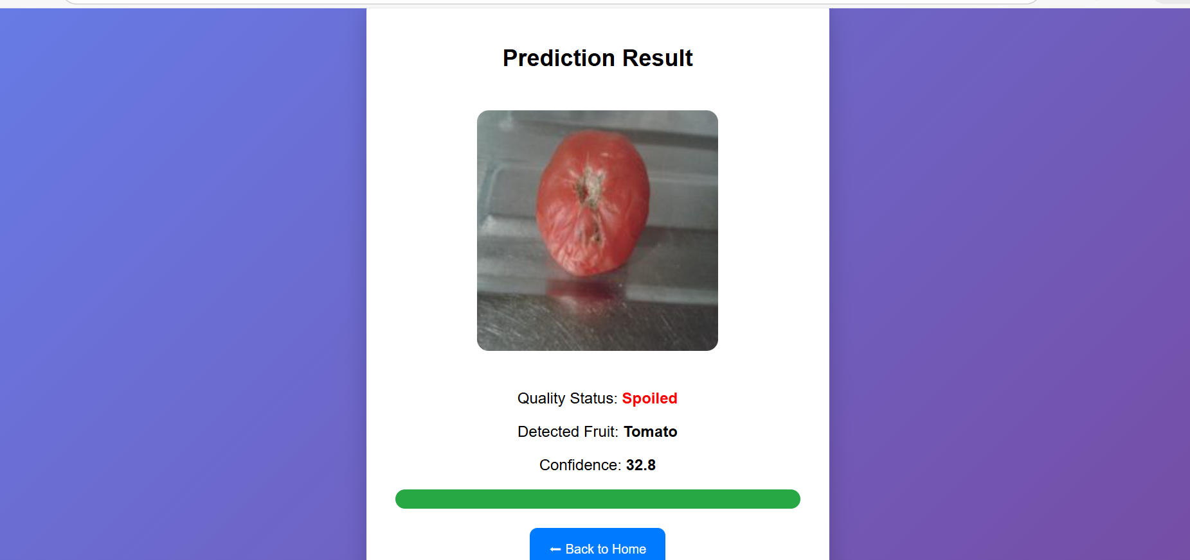

8. ADVANTAGES & DISADVANTAGES

Advantages
- Reduces manual effort
- High accuracy detection
- Fast processing
- Reduces food wastage

Disadvantages
- Limited fruit dataset
- Accuracy depends on image quality
- Requires proper training data

9. CONCLUSION
The Smart Sorting system successfully detects fruit type and classifies quality using deep learning techniques. The system provides an efficient and reliable solution for automated fruit quality inspection and supports smart agriculture and food quality management.

10. FUTURE SCOPE
- Add more fruit categories
- Improve model accuracy
- Cloud deployment
- Mobile application integration
- Real-time camera detection

11. APPENDIX

Source Code
Python, Flask, TensorFlow implementation.

Dataset
Fruit image dataset used for training and testing.

Project Demo / GitHub Link
(Add your GitHub link if available)

